**Openkm configuration in idempiere**

* **Download and setup Openkm –**
  + OpenKm community and Professional both version ‘s are available on (<https://www.openkm.com/en/download.html>) download the suitable version and setup.
  + Now start the server, and login with User ID and password.

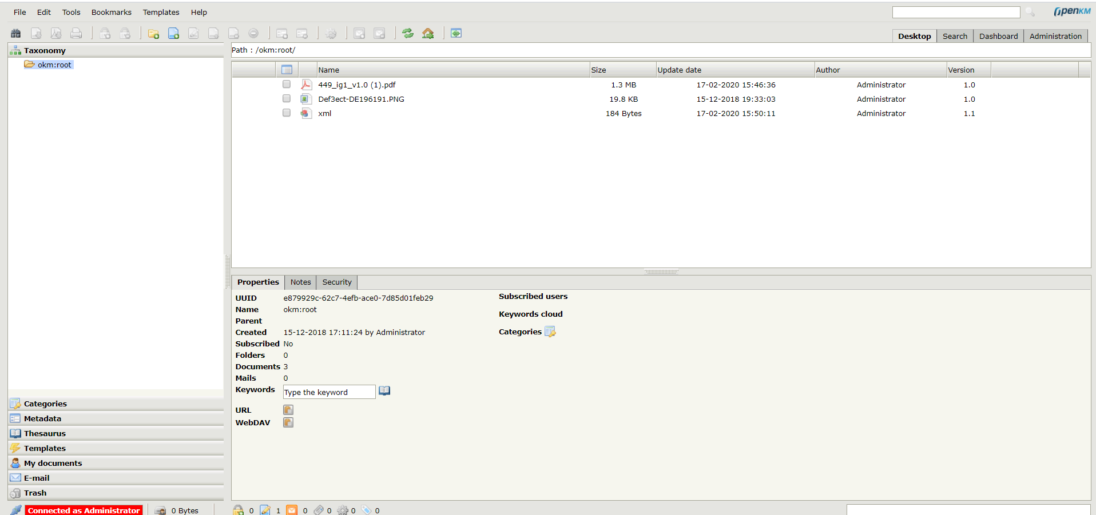

* **iDempiere configuration for Openkm –** 
  + Login with clientadmin and open Client window and navigate to Client Info tab.

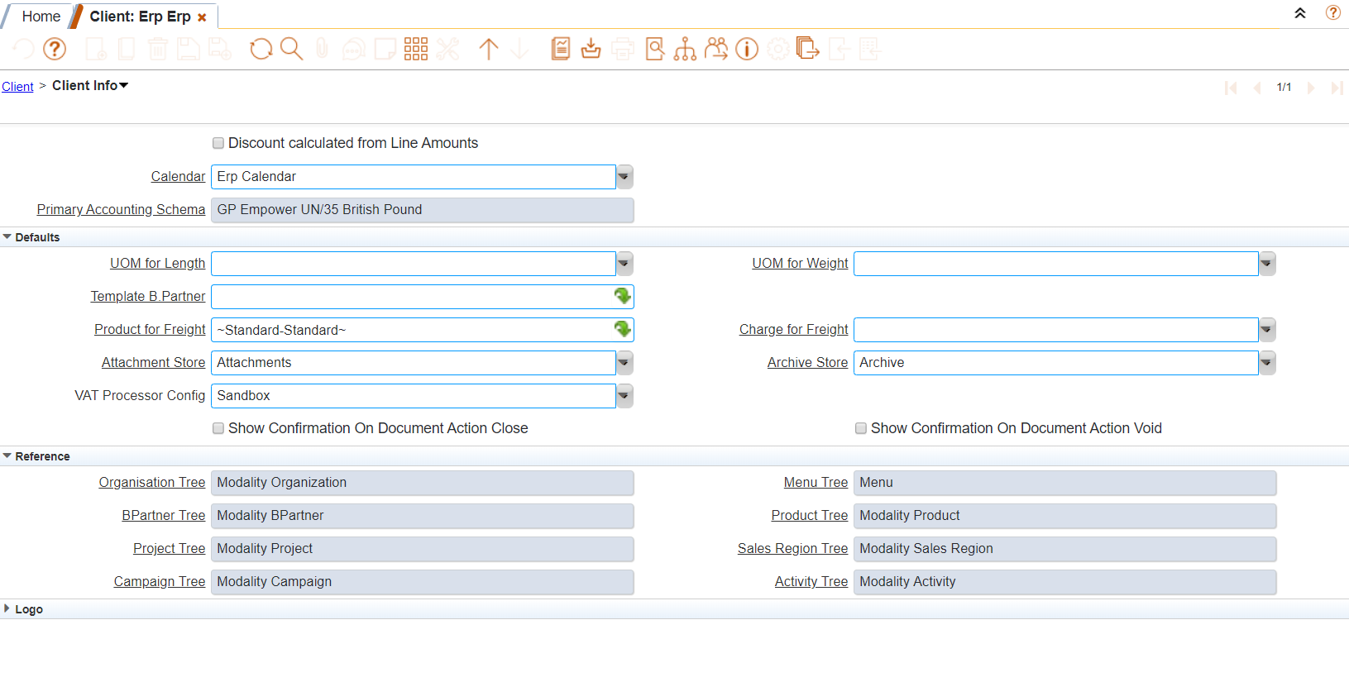

* + Now go to Attachment store and create a new record with openkm environment details.

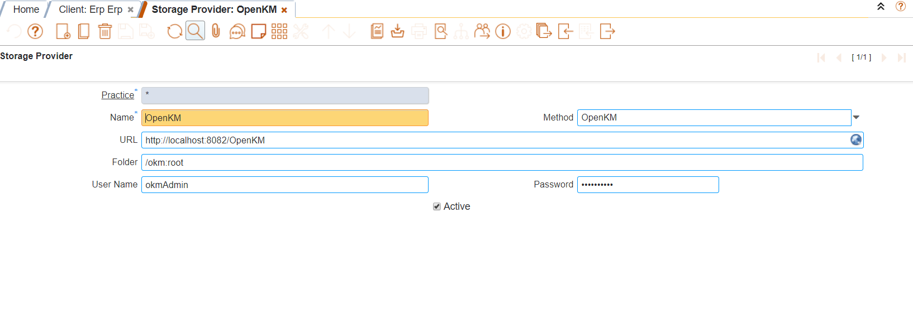

* + Select openkm in attachment store in client info page and save.

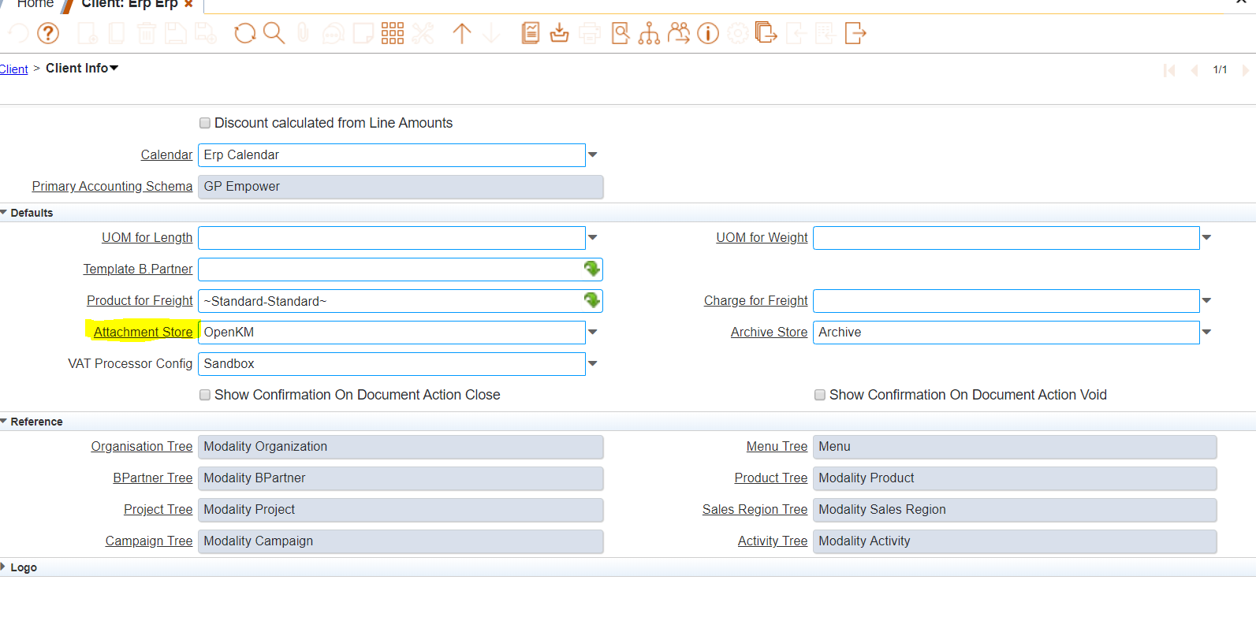

* + Restart the server and try attaching documents.